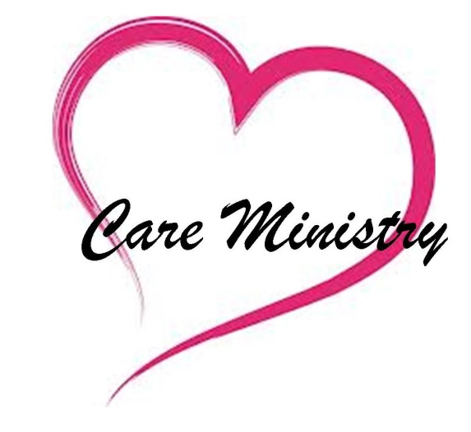

The Care Team is eager to welcome new team members. We are also eager to help you find ways you can serve in care ministries. To get started in care ministries, contact the team leader directly or fill out this tear-off response panel and place in the offering plate any Sunday. You will be contacted by a team member.

Name ___________________________________

Phone __________________________________

E-mail _________________________________

I am interested in:

* Serving on the Care Team in any capacity
* Assembling/delivering care packages
* Visiting the sick
* Planning workshops
* Preparing/delivering meals
* Taking communion to the homebound
* Mailing grief books
* Stephen’s Ministry

*Beloved, I pray that all may go well with you and that you may be in good health, just as it is well with your soul.*

*3 John 1:2*

Care Team

Team Leader:

Terry Granger

301-514-2379

[rtjeb@hotmail.com](mailto:rtjeb@hotmail.com)

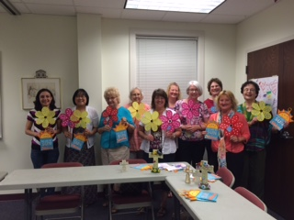



Care Team Mission

The care ministry team provides physical, emotional, and spiritual support to the

Mt. Carmel family and surrounding community.

# Mt. Carmel United Methodist Church

#### Serving with the Care Team

**Care Team**

# The Mt. Carmel Care Team works with our pastors to offer holistic care and compassion to the members and friends of our church family and surrounding community. This brochure provides an overview of the care offered, how you can request care, and opportunities to serve.

# Care Packages & Cards

The Care Team delivers care packages, offers friendly visits, and sends cards to persons who are home bound, in nursing homes, or desire support. The packages include devotional material, treats, seasonal gifts, crafts made by our Sunday School children, etc. If you would like to receive a care package or request one for a member of the community, contact Care Team Leader Terry Granger (301-514-2379).

**Grief Care**.

Mt. Carmel is honored to assist you upon the passing of a loved one. The pastors, church staff and Care Team are available to help you through this difficult time. To receive care upon the loss of a beloved, contact the church office and speak with Donna.

301-662-1303

# Visitation and Prayer

**Emergency Care** – If you are in need of urgent prayer or support, contact our pastors.

Pastor Jeff – 315-729-4464

**Hospitalization** –The Care Team and pastors provide visits to those who are hospitalized. Please let us know when you are in the hospital by contacting the church office at 301-662-1303.

**Surgery and Ongoing Illness** –

We would like to pray with you and offer support during times of surgery and illness. To request support, contact the church office at 301-662-1303 or our pastor directly.

# Wellness Seminars

The Care Team offers several seminars each year that educate and promote awareness around health-related topics. Recent seminars have included, “The Last Best Gift” and “Wholistic Wellness.” To share ideas on seminars or receive more information, contact the Care Team Leader, Terry Granger (301-865-1073).

# Blood Drives

The Care Team hosts American Red Cross Blood Drives annually. Dates are advertised in our bulletins, news-letters and church website. Sign-ups are available at church or on the website.

# Meals Ministry

Our congregation enjoys providing meals for those welcoming a new baby, who have experienced loss or are going through a time of illness or challenge. To request meals for your family or another, the church office at 301-662-1303 or donna.clawson@hopemtcarmel.org



#### Care Team Ministry